BASICS OF AEROMODELLING
Aeromodelling consists of designing, building and flying a small aircraft or drone. To be able to do this first one must know about the basics of aeromodelling and aircrafts in general. And so in the first week of our project we were taught about all the basic parts, motions and types of an aircraft. A plane has to balance the four forces of thrust, drag, lift and weight to fly steadily in air.

Basic motions of an Aircraft:

There are three major types of movements of an aeroplane: -
- Pitch- This is the rotation of an aircraft about the left-right axis passing through the center of the body.
- Roll- This is the rotation of an aircraft about the front-end axis passing though the body of the plane.
- Yaw- This is the rotation of the plane about a vertical z-axis passing through the center of the body of the plane.

Parts of an Aircraft

Various parts of the aircraft work together to help fly a plane: -
- Elevators - The moving section at the rear of the horizontal stabilizer or tailplane that controls the pitch attitude of the airplane.
- Ailerons - Moving section of the trailing edge of the wing, in pairs, (left and right) and work in opposite directions to each other (one up, one down). They roll the model to the left or right.
- Rudder-The moving section on the back half of the fin. Used to control yaw.

The above three parts are also known as the control surfaces of an aeroplane.
  - Horizontal stabilizer-Also called the ‘stab’ or tailplane. The horizontal surface at the back of the fuselage, to which the elevators are attached.
  - Vertical stabilizer- The vertical surface at the back of the fuselage, to which the Rudder is attached.
  - Flaps - Moving sections of the trailing edge of the wing, usually found between the ailerons and fuselage. Used to create more lift at slower flying speeds and also to slow the plane on landing approach.
  - Fuselage - The main body of an aeroplane, excluding wings, tail etc.
  - Airfoils -The cross-section shape of a wing. These are curved surfaces made to provide the greatest ratio of lift to drag so that the plane can fly easily. Types -

    - Symmetrical
    - Flat bottom
    - Under camber

AVIONICS

Avionics are the electronic systems used on aircraft, artificial satellites and spacecraft. Avionics system includes hundreds of systems of which some are following.

Brushless DC motor: These are used to provide power to the propellers so they can rotate.

ESC: Used to control rpm of BLDC motors

Receiver: It receives signals from transmitter and gives output as PMW values.

Transmitter: It transmit the signal received by receiver

Battery: It gives power to the motor.

IMU: It consists of an accelerometer, a gyroscope and a magnetometer.

Flight Controller: It is known as the brain of aircraft. It consists of sensors which helps to detect the movement of drone in flight and also gives the command .

Radio Telemetry: It is used to collect real time data of flight parameters during motion.

GPS: Used to locate and navigate the drone during its motion.

BMP Sensor: Measures pressure and temperature and also used as altimeter.

DEGREES OF FREEDOM OF QUADCOPTER

A QUADCOPTER HAVE FOUR DEGREES OF FREEDOM NAMELY:
1.ROLL- Roll is making the quadcopter fly sidewards, either to left or right. Roll is controlled with the aileron stick, making it move left of right, if you move the aileron stick to the left, the quadcopter will fly left, if you move the aileron stick to right, the quadcopter will fly right.
2.YAW- Yaw is the deviation/Rotating the head of the quadcopter either to right or left, Yaw can be controlled through the throttle stick, also called rudder, making it to rotate either to the left or right. See the below animation to understand more.
3.PITCH- Pitch is the movement of quadcopter either forward and backward. Forward Pitch is achieved by pushing the aileron stick forward, which makes the quadcopter tilt and move forward, away from you.
Backward pitch is achieved by moving the aileron stick backwards(towards you), making the quadcopter, come closer to you. See the below animation to know more about the Pitch movement in quadcopter.
4.THRUST- Thrust is simply for making the quadcopter fly high from the ground/sea level. the elevation can be controlled using the throttle stick, by pushing it forward, making the quadcopter fly high. Pushing the throttle down, makes the quadcopter come down to the ground which is called downfall.

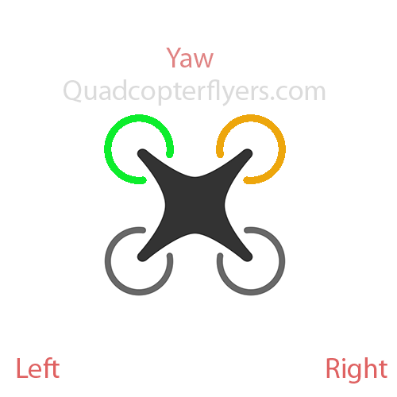
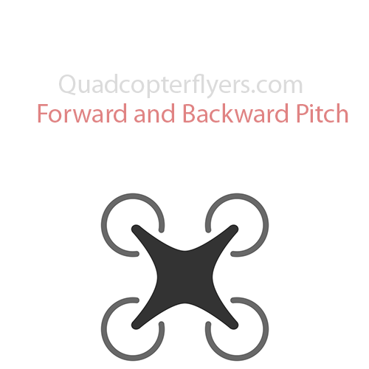
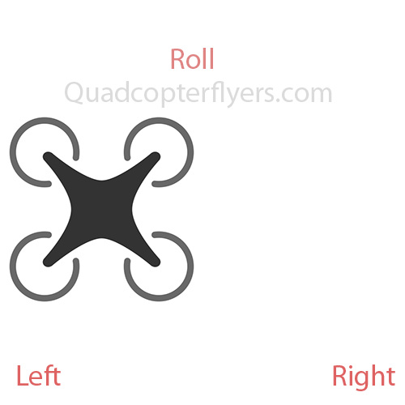

DRONE KINEMATICS
Euler Angles: We define two cartesian frames Body fixed frame and Ground frame, the angles with respect to Body fixed frame are caller Euler angles.
The Roll, Pitch and Yaw angles in body frame are as:
θ = (φ ,θ,ψ)^{T}

Transformation: A rotation matrix M relates the body frame to the ground frame that obtains the ZYX Euler angle conventions:
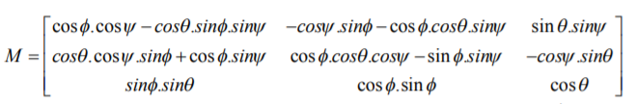

Rotation: When a rotor rotates, it’s propeller produces upward thrust given by F=K_f * ω² where ω (omega) is rotation rate of rotor measured in radian / second.
The total thrust of all motors (quadcopter) on body frame:
F = F1 + F2 + F3 + F4.
Propellers have same size and pitch, so:
F = K_f * (ω₁² + ω₂² + ω₃² + ω₄²)
The rotational torque provided is as :
τ = R × F ;
τ_{yaw} = β * (ω₁² - ω₂² + ω₃² - ω₄²) ;
τ_{pitch} = β’ * (ω₂² - ω₄²) ;
τ_{roll}= β’’ * (ω₁² - ω₃²) .
For hovering, all the ω_{i} (omega) are equal to each other.

Angular Velocity: Let ω = [p, q, r] ^{T} is the angular velocity vector, I is the inertia matrix, then,
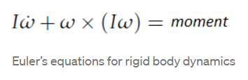

Do not confuse this ‘ω’ with the angular speed of rotors, this is the angular velocity of the drone around the three axes.

The angular velocities are with respect to ground frame but we require them with respect to Body frame and hence a rotation matrix is used to transform the angular velocities.

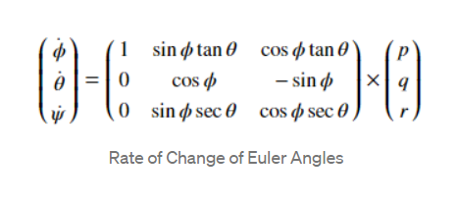

BASICS OF CONTROLLING.
Stability: the more the number of propellers more will be the stability of the drone. Use some angle of the arms with the horizontal to reduce distortion and with the help of speed controller we can improve the stability according to height and pressure.
Gyroscope: micro-electro-mechanical system (MEMS) gyroscope are used to measure rate of rotation of object about an axis to make the device stable and take it to desired direction.
Magnetometer: Using a magnetometer on a drone enables us to scan the area and detect metals several times faster compared with handheld devices and allows obtaining geo-referenced maps of the area. They are of two types: Absolute and Relative and depends on the calibration.
Barometer: it is used to measure the height of object with the help of atmospheric pressure changes around it and helps in reaching the desired height.
Accelerometer: they are used to determine the position and orientation of the drone in flight. They are also based on MEMS, it is a device that measures the vibration, or acceleration of motion of a structure. The force caused by vibration or a change in motion (acceleration) causes the mass to "squeeze" the piezoelectric material which produces an electrical charge that is proportional to the force exerted upon it.

Control Theory:
Control theory gives the idea of autonomous control of a system. Much of the control theory focuses on modeling physical systems as linear and time invariant. Such LTI systems follow the superposition principle, homogeneity principle and law off time invariance. LTI model is useful in modelling electrical and mechanical systems.
Purely no linear time invariant system exist but most of the systems behaves in this manner under some conditions the mathematical form of Laplace transformation is here .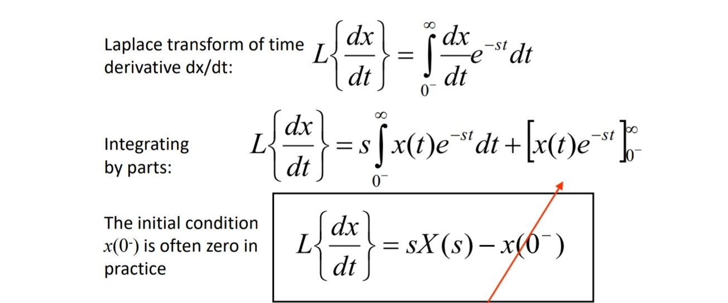
PID CONTROLLERS:
Most of the linear time invariant systems can be controlled by PID controller. PID stands for Proportional, Integral and Differentiable. All these three kinds of controllers work simultaneously.
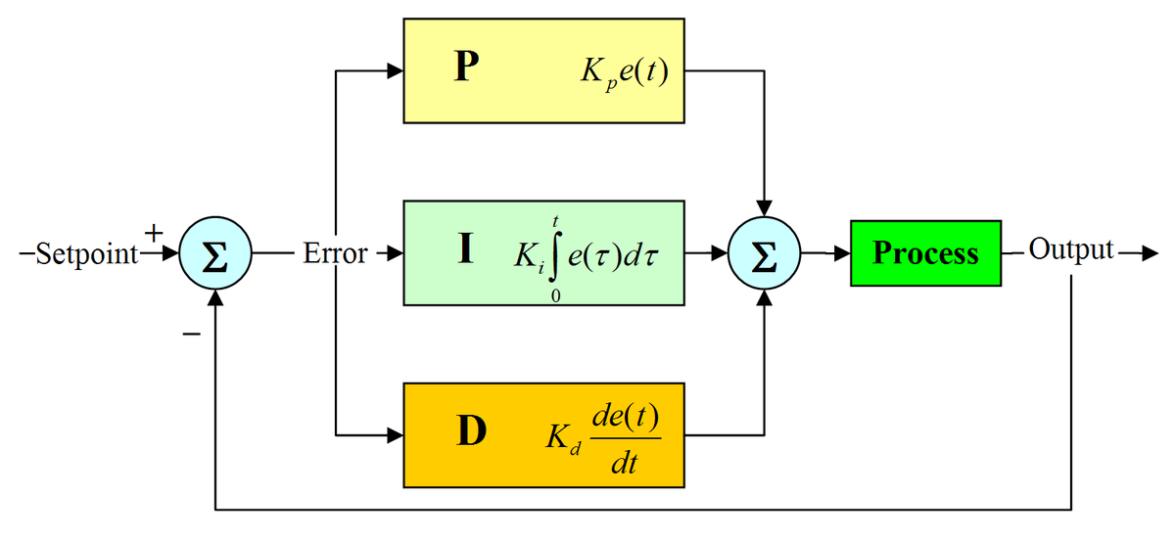

This control is based on feedback mechanism and verbs for reducing error with time.

UBUNTU INTALLATION
Step 1: Create a live USB or disk Download ubuntu and create a live USB or DVD

Step 2: Boot in to live USB
Plug the live USB or disk in to the computer and restart the computer. While booting the computer press F10 or F12 function key (defers from computer to computer) to go to the boot menu. Now, choose the option to boot from USB or Removable Media.

Step 3: Start the installation Once booted, you will be immediately provided with option to either try Ubuntu or install Ubuntu. Even if you choose to try, you can find the option to install on the desktop.
In the Installation Type window, choose Something Else.

Step 4: Prepare the partition
What you need to do here is to delete a NTFS or existing ext4 partition and create some free space. This will delete all the data in that partition and make sure that you have Windows installed in a different partition. Click on the desired partition and press the – to delete the partition.

Step 5: Create root, swap and home
Create a root partition first. Choose the free space available and click on +.
Here choose the size of root directory (keep it 20 GB or more), choose ext4file system, and mount point as / (i.e. root). Next step is to create swap partition. It is advised by many that Swap should be double of your system’s RAM size. You can choose the swap size accordingly. The next step is to create Home. Try to allocate the maximum size to Home because this is where you’ll be downloading and keeping the files. Once you have created Root, Swap and Home partitions, click on Install Now button.

Step 6: Follow the trivial instructions
You will be taken through a number of screens to select options like keyboard layout, login credentials etc. You don’t have to be a genius to figure out what to do here afterwards.
Once the installation is over, you will be presented with the option to keep trying live version or to restart the system.
And that’s it. On next boot, you will see the option of Ubuntu in the grub screen.

MISSION PLANNER INSTALLATION

Step 1: Go to this link https://ardupilot.org/planner/docs/mission-planner-advanced-installation.html.

Step 2: Then click on “here” the link under the heading “Download the most recent Mission Planner ZIP Files” where zip or msi files of all versions of mission planner are there.

Step 3: Then download the zip file of the required version and then unzip the file.
MENTORS:
- PRANSHU SINGHAL
- RAJ AGARWAL
- MOHIT ANAND
- MOIN AHMED

TEAM MEMBERS:
- PRANSHU
- UTKARSH
- NITIN
- SHEESHRAM
- AYUSH
- AKANKSHA
- SAURABH

